For your FYP final presentation on "IoT and Computer Vision Based Smart Stick for Visually Impaired Persons", examiners usually ask questions from hardware, software, IoT, computer vision, power management, and project integration.

Project Overview Questions
- What problem does your smart stick solve?
- How is your stick different from a traditional white cane?
- Why did you choose IoT and Computer Vision together?
- What are the main objectives of your project?
- What are the limitations of your system?
- What is the overall working flow of the project?
- What are the future improvements?

ESP32 Questions
ESP32
- Why did you choose ESP32 instead of Arduino Uno?
- What are the main features of ESP32?
- What is the clock speed of ESP32?
- How much RAM and Flash memory does ESP32 have?
- What communication protocols does ESP32 support?
  - Wi-Fi
  - Bluetooth
  - UART
  - SPI
  - I2C
- Why is ESP32 suitable for IoT applications?
- What operating voltage does ESP32 use?
- What happens if ESP32 receives more than 3.3V on GPIO pins?
- How does ESP32 connect to the internet?

Sample Answer
"ESP32 was selected because it provides built-in Wi-Fi and Bluetooth, high processing power, multiple GPIOs, and low power consumption, making it ideal for IoT-based smart assistive devices."

ESP32-CAM Questions
ESP32-CAM
- What is ESP32-CAM?
- Which camera module is used on ESP32-CAM?
- Why did you use ESP32-CAM instead of a normal camera?
- How does image capture work?
- How is computer vision implemented?
- What objects can your system detect?
- What image resolution is used?
- What are the limitations of ESP32-CAM?
- Why is computer vision important for visually impaired people?
- What machine learning or AI model did you use?

Sample Answer
"ESP32-CAM captures images and sends them for processing. The detected object information is converted into voice feedback for the user."

Ultrasonic Sensor Questions
HC-SR04 Ultrasonic Sensor
- What is the purpose of the ultrasonic sensor?
- How does it measure distance?
- What is the operating principle?
- What is the frequency of ultrasonic waves?
- What is the detection range?
- What is the accuracy?
- What happens if an obstacle is too close?
- Why use ultrasonic sensors along with a camera?

Important Formula

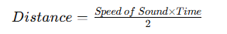

Sample Answer
"The ultrasonic sensor emits ultrasonic waves and measures the echo return time to calculate obstacle distance."

DFPlayer Mini Questions
DFPlayer Mini
- What is DFPlayer Mini?
- Why is it used in your project?
- How does it communicate with ESP32?
- Which audio formats are supported?
- What is the function of the SD card?
- How many audio files can it store?
- Why did you use voice output instead of a buzzer only?

Sample Answer
"DFPlayer Mini plays prerecorded voice instructions stored on the SD card to guide visually impaired users."

Memory Card Questions
microSD Card
- Why did you use a 16 GB memory card?
- What data is stored on it?
- Could a smaller card work?
- Which file system format is required?
- How does DFPlayer access audio files?

Buzzer Questions
Buzzer
- Why use a buzzer when voice messages already exist?
- What is the difference between active and passive buzzers?
- When does the buzzer activate?
- What are the advantages of buzzer alerts?

Sample Answer
"The buzzer provides immediate warning alerts while voice messages provide detailed guidance."

Power Bank Questions
10000 mAh Power Bank
- Why did you use a power bank?
- Why 10000 mAh capacity?
- How long can the system operate?
- What output voltage does the power bank provide?
- Can the system run continuously?

Calculation Question

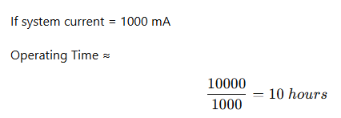

Capacitor Questions

47 µF Capacitor
47 µF Capacitor
- Why use a 47 µF capacitor?
- What is the role of filtering?
- Why is the voltage rating 35V?

470 µF Capacitor
470 µF Capacitor
- Why use a larger capacitor?
- How does it stabilize voltage?
- Why is it useful near DFPlayer or power supply lines?

Sample Answer
"Capacitors smooth voltage fluctuations and reduce noise in the circuit."

Resistor Questions

Resistor
- What is the function of a resistor?
- What is Ohm's Law?
V=IR
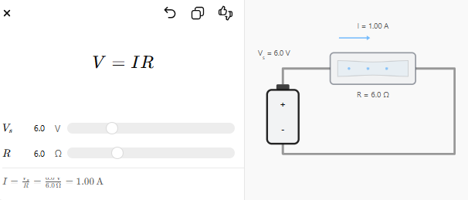
- Why are resistors used with LEDs?
- How do you calculate resistor values?
- What happens if no resistor is used?

Voltage Divider Questions
Voltage Divider
- What is a voltage divider?
- Why is it needed with ESP32?
- Why convert 5V signals to 3.3V?
- Which components create a voltage divider?
- What formula is used?
- 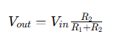

Sample Answer
"A voltage divider reduces the ultrasonic sensor's 5V Echo signal to 3.3V so it can safely connect to ESP32."

Vero Board Questions
Vero Board
- What is a Vero board?
- Why use it instead of a breadboard?
- What are its advantages?
- Is it suitable for permanent circuits?

IoT Questions
Internet of Things
- What is IoT?
- How does your device connect to the internet?
- What data is transmitted?
- Why is cloud connectivity useful?
- Can family members monitor the user remotely?
- What security issues exist in IoT systems?

Computer Vision Questions
Computer Vision
- What is computer vision?
- How does object detection work?
- Which model did you use?
- What is image classification?
- What is object recognition?
- What challenges occur in low light?
- What is detection accuracy?

Frequently Asked Viva Question
Q: Why did you use both an ultrasonic sensor and a camera?
Answer:
"The ultrasonic sensor provides fast and reliable distance measurement, while the camera identifies the type of object. Combining both improves safety and navigation accuracy for visually impaired users."
Q: What is the most innovative feature of your project?
Answer:
"The integration of IoT, computer vision, obstacle detection, and voice guidance into a portable smart stick for visually impaired users."

